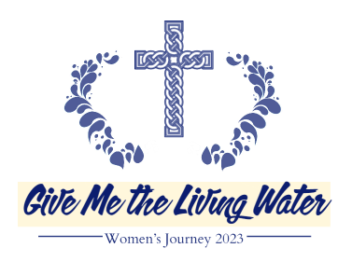
20th Women’s Journey Retreat, March 10-12, 2023
“Give Me the Living Water”
Registration Form or online at www.coloradocatholicretreats.org
Registration Deadline is March 5, 2023
Small groups: A significant part of the retreat is the small-group experience. If you are attending with another woman or women with whom you would like to be in a small group, please indicate their name(s) on this form. Groups typically are between 6 and 8 women. If there are fewer listed, you may be placed with other women to make a full group. We do our best to honor your request and place you together with the women you request, but sometimes the Holy Spirit intervenes. We pray over your names as we create small groups, knowing His wisdom prevails. We have learned over the last 19 years that each woman is placed in her group for a reason.
Be a Facilitator: Each small group needs a facilitator who is the “point person” to relay information from the core team to your group and present the reflection questions. It is an important role and if you have attended the Journey before, then please consider being a facilitator for your group. We will contact you before the retreat with more information.
Please Print Clearly
Name_________________________________________________________ Best Telephone Number________________
Address____________________________________ City _______________________ State _______ Zip code_________
Email__________________________________________________ Age _____ Single Married Separated Divorced
Parish ____________________________________________________________________
Have you attended the retreat before? Yes No
Please describe any physical disabilities we need to know about:______________________________________________
I would like to room with: _________________________
______________________________________________________________________________________________
I am willing to be a facilitator.
I would like to be in a small group with: ______________
_____________________________________________________________________________________________________________________________________________
Please choose one:
Our group is open: we would like other women to join us.
Our group is closed: we are a complete group.
I have no preferences for the group I am in.
Carpool Information: Do you need a carpool? ____
Are you willing to drive other women? ____ Email Karen Smoody before March 5th at KSMOOTHIE56@GMAIL.COM or call 303-588-0461. She will email you March 8.
Staff use only.
Payment ___________ Room _______ Group ___________

Includes: 3 meals Sat., 1 meal Sun.
Each room has two queen sized beds.
Price is per person (please check one)
1 woman in a private room - $295
2 women sharing one room - $195 per person
3 women sharing one room - $175 per person
Self arranged cabin - $125 per person (Retreat fee includes meals)*
*We will not reserve a cabin for you. They differ in size and price. If you would like to reserve a cabin, then please call the YMCA directly at 970-586-3341 to arrange and pay for lodging.
Payment
Online registration/payment are preferred at www.coloradocatholicretreats.com, however, you may make a check payable to “Colorado Catholic Retreats” and mail it and this registration form to:
Patti Hayes – Women’s Journey
c/o Spirit of Christ Catholic Community
7400 West 80th Avenue, Arvada, CO 80003
Questions: Please text or call Patti Hayes at 720-608-1607 or email her at PHAYES@SPIRITOFCHRIST.ORG.
Confirmation email with further details will be sent to you upon receipt of completed registration.
Cancellation fee of $50.00 will be assessed if we are unable to fill your reservation.

20th Women’s Journey Retreat, March 10-12, 2023
YMCA of the Rockies 2515 Tunnel Road Estes Park, CO 80511
www.coloradocatholicretreats.org
The retreat starts Friday evening at 6:45 PM and concludes Sunday at noon.

You are invited to join Catholic and Christian women to share reflections on your lives and spiritual journeys.
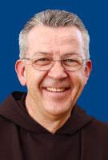
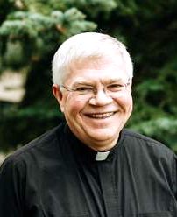
The weekend retreat is presented by a group of committed lay women, Sisters of Life and two dynamic Catholic priests:

Fr. Doug Grandon
Fr. John Lager, a Capuchin Franciscan Friar

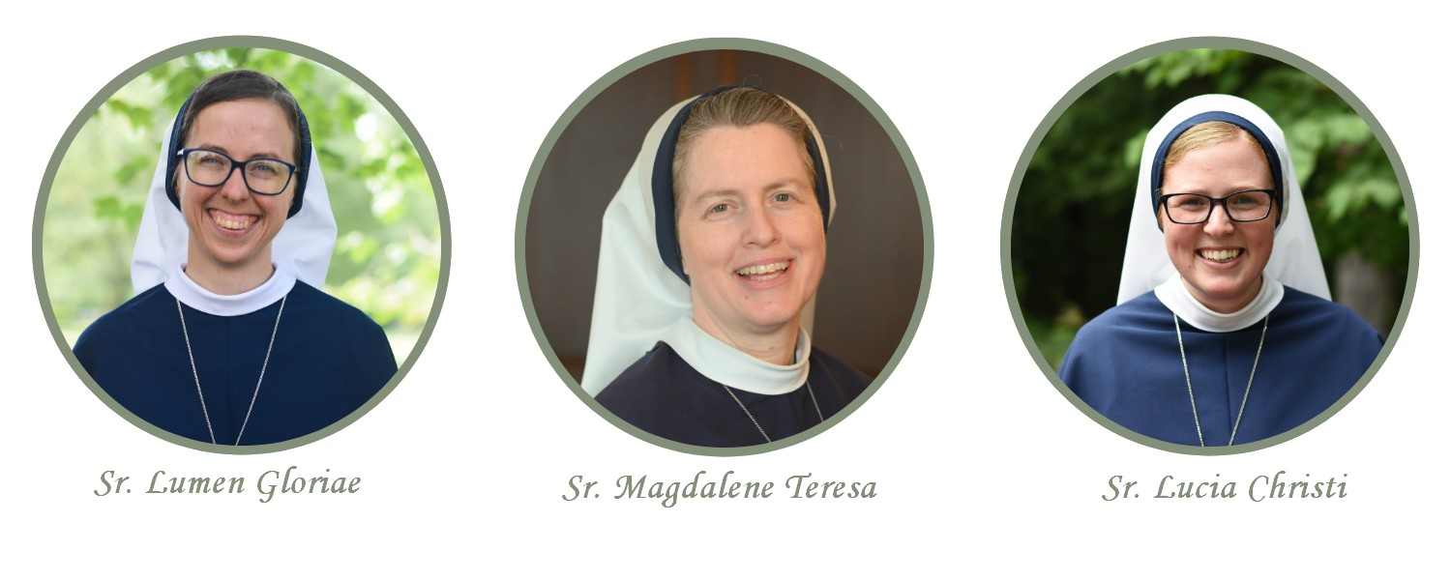
The Sisters of Life are a religious community of women founded in 1991 by John Cardinal O’Connor who take a fourth vow to protect and enhance the sacredness of human life. Immersed in Eucharistic prayer within a vibrant community life, their missions include caring for vulnerable pregnant women and their unborn children; inviting those wounded by abortion into the healing mercy of Jesus; fostering a Culture of Life through evangelization; retreat works; spiritual accompaniment of college students; and upholding the beauty of marriage and family life. The Sisters look forward to accompanying you on the Women's Journey retreat this year, and are praying for you as we await this grace-filled weekend! You may find out more about them at sistersoflife.org

The retreat is the third weekend of Lent. Come reflect, pray, support, and be supported by other women of faith, as you Journey through Lent. We welcome you to journey up the mountain to experience God’s love, healing and peace!
--Our mission is to grow in our Christian spirituality and wholeness with the support of other women.—

